Network Devices & Local Area Network (LAN)

Introduction
A network device is a hardware component used to connect computers, servers, printers, and other electronic devices to form a communication network. These devices enable communication by transmitting, receiving, routing, and managing data across the network.

1. Network Interface Card (NIC)

Definition
A Network Interface Card (NIC) is a hardware component that allows a computer to connect to a wired or wireless network.

Features
- Operates at Layer 1 (Physical) and Layer 2 (Data Link).
- Has a unique 48-bit MAC Address assigned by the manufacturer.
- Available in Ethernet (wired) and Wi-Fi (wireless) versions.
- Converts digital data into electrical, optical, or wireless signals.

Advantages
- Enables communication between computers.
- Provides high-speed network connectivity.
- Supports both wired and wireless networking.
- Does not reduce network congestion.
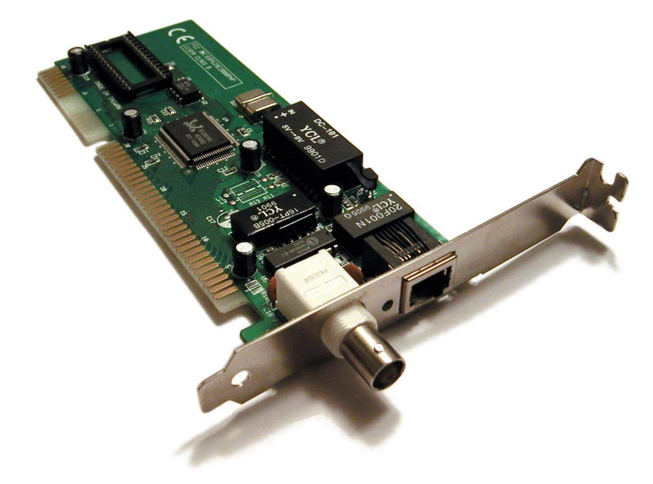

2. Repeater

Definition
A Repeater is a networking device that regenerates weak signals and retransmits them over longer distances.

Features
- Operates at Layer 1 (Physical).
- Regenerates weak signals.
- Does not inspect data or addresses.
- Usually has two ports.

Advantages
- Extends network coverage.
- Improves signal quality.

Disadvantages
- Cannot filter traffic.
- Does not reduce network congestion
.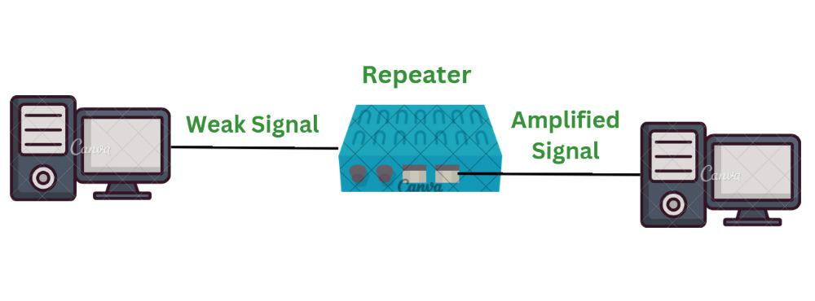
3. Hub
Definition
A Hub is a multi-port repeater that broadcasts incoming data to all connected devices.
Features
- Operates at OSI Layer 1 (Physical Layer)
- Broadcasts data to every connected device
- Single collision domain
- Single broadcast domain
- Supports half-duplex communication
Advantages
- Low cost
- Easy to install
- Simple to use
Disadvantages
- Causes frequent network collisions
- Low performance
- No security or traffic filtering
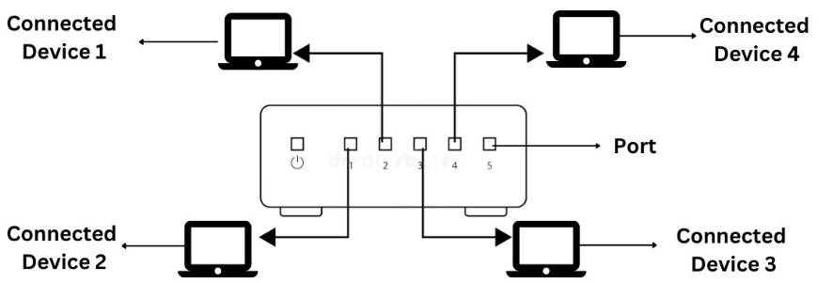

4. Bridge
Definition
A Bridge connects two LAN segments and forwards frames using MAC addresses.
Features
- Operates at OSI Layer 2 (Data Link Layer)
- Learns MAC addresses
- Filters unnecessary traffic
- Reduces collisions
- Connects two LAN segments
Advantages
- Improves network performance
- Reduces unnecessary traffic
- Decreases collisions
Disadvantages
- Supports only a limited number of LAN segments
- Slower than modern switches
- Becoming less common 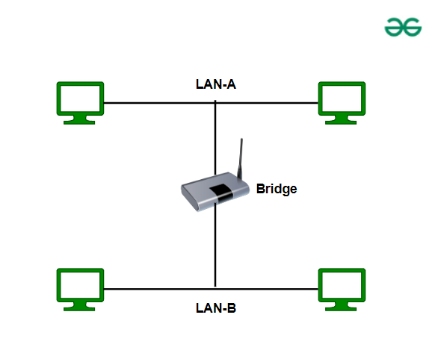

5. Switch
Definition
A Switch is a multi-port bridge that forwards data only to the destination device using MAC addresses.
Features
- Operates at OSI Layer 2 (Data Link Layer)
- Uses a MAC Address (CAM) Table
- Supports full-duplex communication
- Each port has its own collision domain
- Single broadcast domain (unless VLANs are configured)
Types of Switches
- Unmanaged Switch
- Managed Switch
- PoE (Power over Ethernet) Switch
- Layer 3 Switch
Advantages
- High-speed communication
- Reduces collisions
- Efficient bandwidth utilization
- Improves network performance
Disadvantages
- More expensive than hubs
- Managed switches require configuration
- Broadcast traffic still exists without VLANs 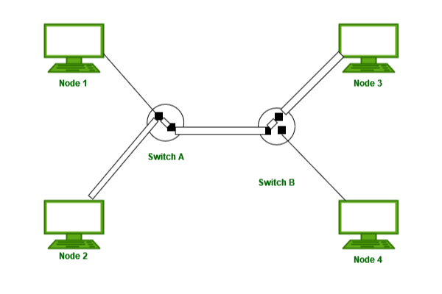

6. Router
Definition
A Router connects different networks and forwards packets using IP addresses.
Features
- Operates at OSI Layer 3 (Network Layer)
- Uses IP addresses for routing
- Maintains routing tables
- Performs Network Address Translation (NAT)
- Connects LANs to WANs or the Internet
Advantages
- Connects multiple networks
- Separates broadcast domains
- Provides Internet connectivity
- Supports security features like ACLs and firewalls
Disadvantages
- Higher cost
- More complex configuration
- Slower than switches for local traffic 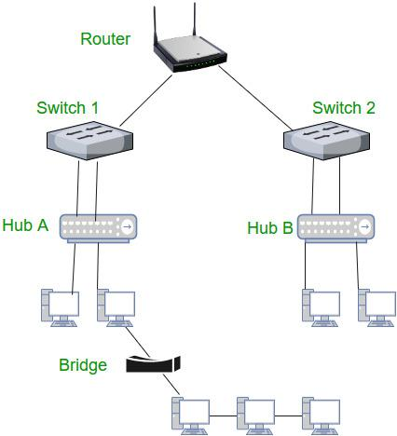

7. Gateway
Definition
A Gateway connects networks using different communication protocols and acts as a protocol translator.
Features
- Operates across multiple OSI layers (commonly Layer 7)
- Performs protocol conversion
- Connects different network architectures
- Often integrated with routers
Advantages
- Enables communication between different protocols
- Supports protocol translation
- Allows interoperability between dissimilar networks
Disadvantages
- Expensive
- Complex to configure and maintain
- 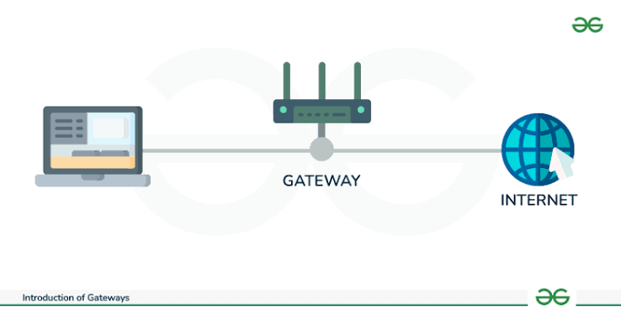

Comparison of Network Devices
Device | OSI Layer | Forwarding Based On | Collision Domain | Broadcast Domain
Hub | Layer 1 | Signal | One (Shared) | One
Bridge | Layer 2 | MAC Address | One per Segment | One
Switch | Layer 2 | MAC Address | One per Port | One
Router | Layer 3 | IP Address | One per Port | One per Interface

PAN (Personal Area Network)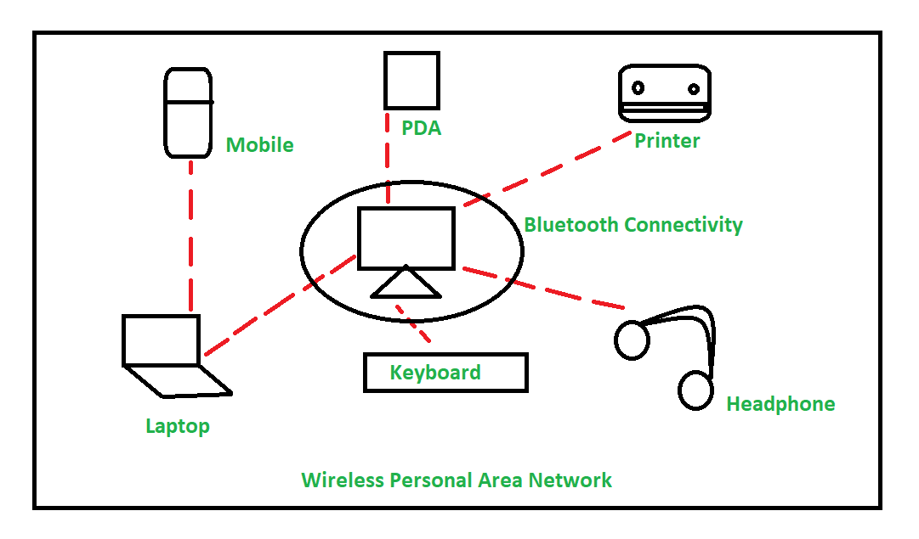
PAN (Personal Area Network) is a computer network used to connect devices around a single person within a short range. It is mainly used for communication and data sharing between personal devices such as smartphones, laptops, tablets, smartwatches, and headphones. PAN can use wired technologies like USB or wireless technologies like Bluetooth.

Characteristics of PAN
- It covers a very small geographical area.
- It is mainly used by an individual person.
- It connects personal electronic devices.
- It can be wired or wireless.
- Bluetooth and USB are commonly used technologies.
- It is easy to set up and use.
- It requires less cost compared to larger networks.

Advantages of PAN
- Easy to Use: PAN is simple to set up and operate.
- Low Cost: It requires fewer devices and less infrastructure.
- Convenient: It allows easy connection between personal devices.
- Data Sharing: Files and information can be shared between connected devices.
- Portable: Devices can be connected while moving within the network range.
- Low Power Consumption: Wireless PAN technologies such as Bluetooth generally consume less power.

Disadvantages of PAN
- Limited Range: It covers only a small area.
- Limited Number of Devices: Only a limited number of devices can be connected effectively.
- Low Data Transfer Speed: Some PAN technologies may provide lower speeds than LAN or other larger networks.
- Security Issues: Wireless PAN connections can be vulnerable if proper security settings are not used.
- Limited Applications: It is mainly suitable for personal use and not for large organizations.

LAN Cable

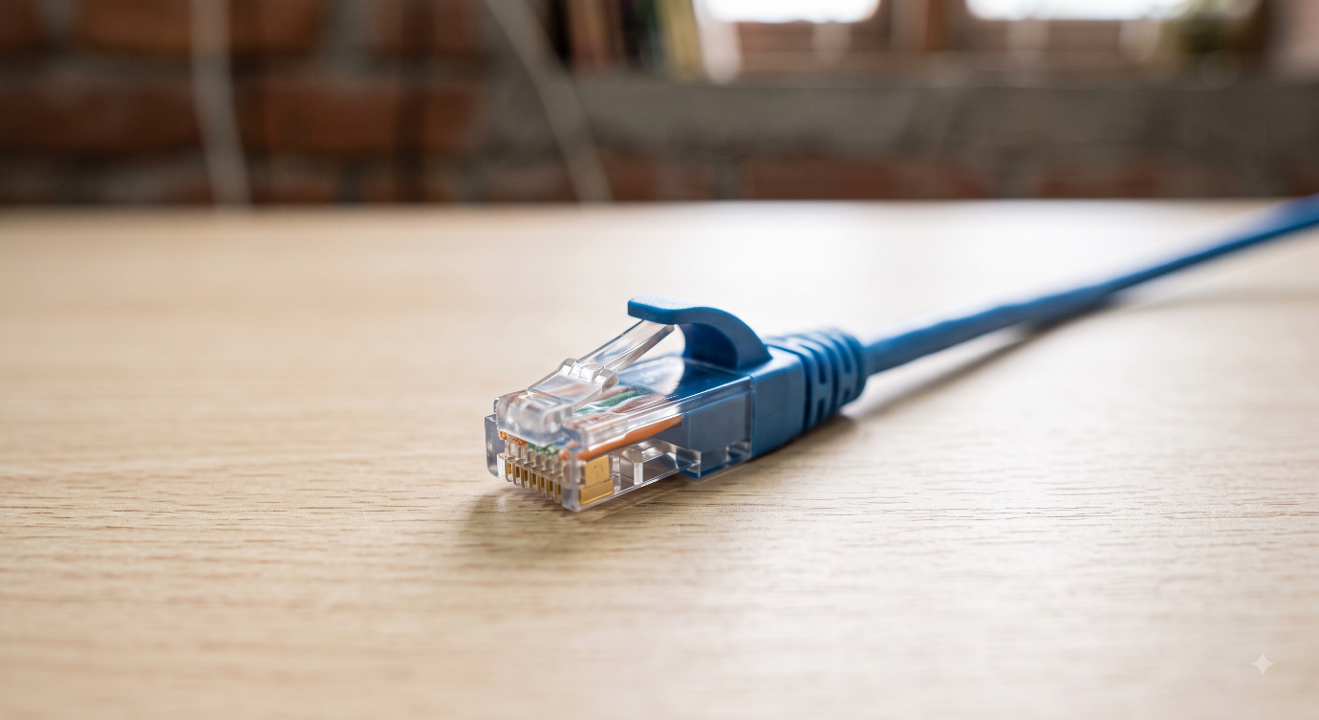
A LAN (Local Area Network) Cable is a type of network cable used to connect computers, routers, switches, and other network devices. It is mainly used for transferring data between devices in a local network. Common types of LAN cables include Cat5e, Cat6, and Cat6a cables.

Characteristics of LAN Cable
- It provides a wired connection between network devices.
- It supports high-speed data transmission.
- It provides a stable and reliable network connection.
- It usually uses copper wires to transmit data.
- It has lower latency compared to many wireless connections.
- It is easy to install and maintain.
- Different cable categories support different data speeds and bandwidths.

Advantages of LAN Cable
- High Speed: It provides fast data transfer between connected devices.
- Reliable Connection: It offers a stable and consistent network connection.
- Low Latency: It provides quick data transmission with less delay.
- Better Security: A wired connection is generally more difficult to access without physical network access.
- Cost Effective: LAN cables are relatively inexpensive and easy to use.
- Easy Installation: They can be easily installed and connected to network devices.
- No Wireless Interference: They are less affected by wireless signal interference.

Disadvantages of LAN Cable
- Limited Mobility: Devices must remain connected to the cable.
- Cable Length Limitation: The distance of a wired connection is limited.
- Physical Damage: Cables can be damaged, cut, or disconnected.
- Cable Management: A large number of cables can make the network difficult to organize.
- Less Flexibility: Devices cannot be freely moved like wireless devices.
- Installation Work: Installing cables over large areas can require additional time and effort.

CAN (Campus Area Network)

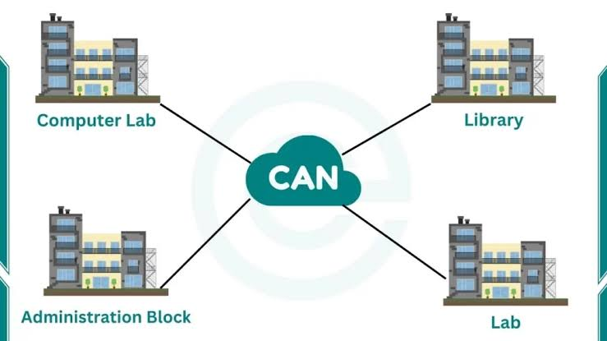
CAN (Campus Area Network) is a computer network that connects multiple LANs within a limited geographical area, such as a school, college, university, or corporate campus. It is larger than a LAN but smaller than a MAN or WAN. CAN is used to share resources, data, internet connections, and other network services between different buildings or departments.

Characteristics of CAN
- It covers a limited geographical area such as a campus.
- It connects multiple LANs together.
- It provides high-speed communication between connected devices.
- It is usually managed by a single organization.
- It allows sharing of resources and network services.
- It is more extensive than a LAN.
- It can connect different buildings within the same campus.

Advantages of CAN
- High Speed: Provides fast communication between different buildings and departments.
- Resource Sharing: Allows users to share printers, files, servers, and internet connections.
- Centralized Management: The entire network can be managed by one organization.
- Better Communication: Makes communication between departments easier.
- Cost Effective: Shared resources can reduce overall infrastructure costs.
- Scalable: Additional buildings and devices can be added when required.

Disadvantages of CAN
- High Installation Cost: Setting up a campus-wide network can be expensive.
- Complex Management: Managing multiple LANs can be more difficult.
- Maintenance: Regular maintenance and technical support are required.
- Security Risks: A larger network may have more security threats.
- Limited Coverage: It is generally limited to a particular campus or organization.
- Network Failure: A major network problem can affect multiple connected departments.

MAN (Metropolitan Area Network)

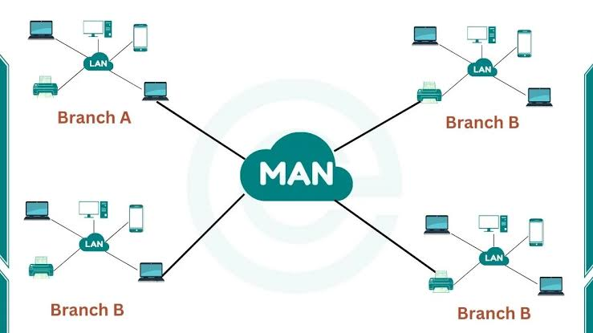
MAN (Metropolitan Area Network) is a computer network that covers a larger geographical area than a LAN but smaller than a WAN. It is mainly used to connect computers and networks across a city or metropolitan area. MAN can connect different offices, colleges, branches, or organizations within a city.

Characteristics of MAN
- It covers a large geographical area, usually a city or metropolitan area.
- It is larger than LAN and smaller than WAN.
- It connects multiple LANs together.
- It provides high-speed data communication.
- It can be operated by a private organization or service provider.
- It uses technologies such as fiber-optic cables and wireless links.
- It is suitable for connecting different branches within a city.

Advantages of MAN
- High Speed: Provides fast data transmission over a large area.
- Resource Sharing: Allows sharing of files, servers, and other network resources.
- Wide Coverage: Covers a larger area than LAN.
- Better Communication: Makes communication between different offices and branches easier.
- Cost Effective: Shared network infrastructure can reduce communication costs.
- Reliable: Provides a stable connection between different locations.

Disadvantages of MAN
- High Cost: Installation and maintenance can be expensive.
- Complex Management: Managing a large network requires skilled professionals.
- Security Issues: Larger networks may face more security threats.
- Maintenance: Regular maintenance is required.
- Technical Problems: Network failures can affect many connected locations.
- Limited Coverage: It generally covers only a city or metropolitan area.

WAN (Wide Area Network)

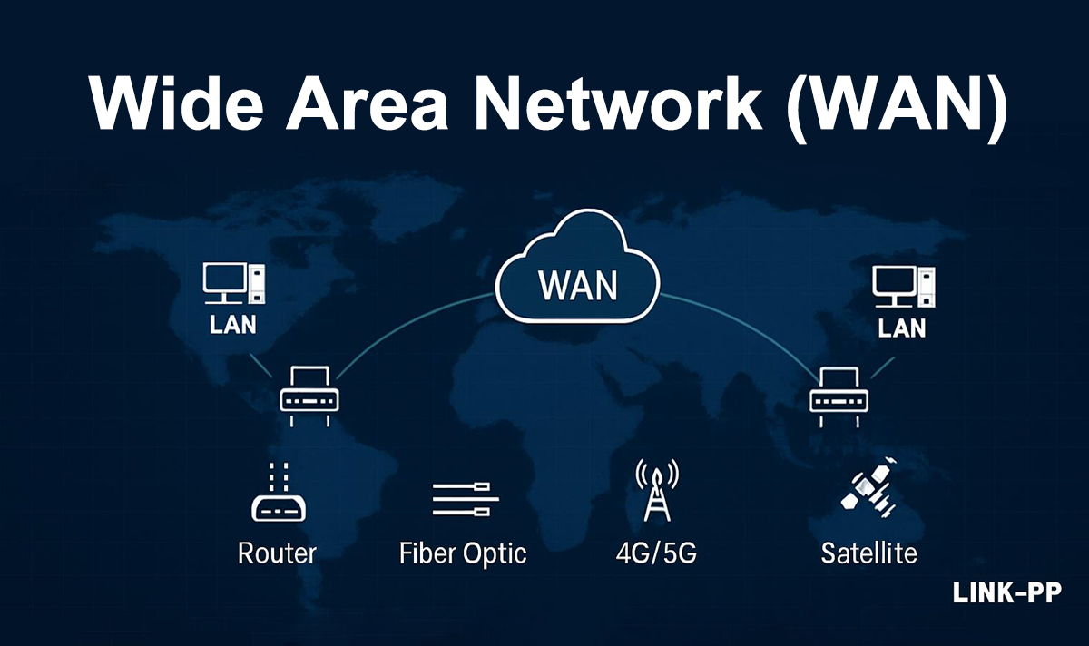
WAN (Wide Area Network) is a computer network that covers a very large geographical area, such as countries, continents, or even the entire world. It connects multiple LANs and MANs through communication technologies such as fiber-optic cables, satellites, and leased lines. The Internet is the largest example of a WAN.

Characteristics of WAN
- It covers a very large geographical area.
- It can connect networks across cities, countries, and continents.
- It connects multiple LANs and MANs.
- It uses wired and wireless communication technologies.
- It provides long-distance data communication.
- It is generally more complex than LAN and MAN.
- It may be managed by multiple organizations or service providers.

Advantages of WAN
- Large Coverage: It connects devices and networks over long distances.
- Resource Sharing: Users can share files, applications, servers, and other resources.
- Global Communication: It enables communication between people and organizations across different locations.
- Centralized Data: Data and applications can be accessed from different locations.
- Business Connectivity: It helps organizations connect their branches in different cities or countries.
- Remote Access: Users can access network resources from different locations.

Disadvantages of WAN
- High Cost: Setting up and maintaining a WAN can be expensive.
- Security Risks: Large networks are more exposed to cyber threats.
- Complex Management: WANs require skilled professionals for management and maintenance.
- Lower Speed: Data transmission may be slower than a local network such as LAN.
- Maintenance: Regular maintenance and technical support are required.
- Network Failure: Problems in network infrastructure can affect communication across multiple locations.

WLAN – Wireless Local Area Network

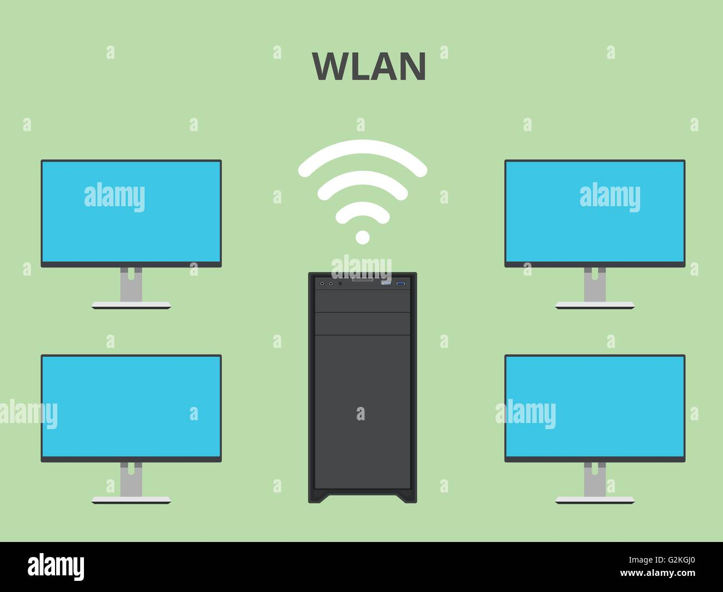
Definition:
WLAN is a network that connects computers and other devices within a limited area without using physical cables, mainly through wireless communication.

Characteristics
- Covers a small geographical area such as a home, office, or college.
- Uses wireless technologies such as Wi-Fi.
- Allows devices to communicate without network cables.
- Easy to install and expand.
- Usually connected through a wireless access point or router.

Advantages
- No need for physical cables.
- Easy to install and configure.
- Devices can be moved while remaining connected.
- Easy to add new devices.
- Useful in homes, offices, schools, and public places.

Disadvantages
- Security risks if not properly protected.
- Signal strength can decrease with distance.
- Interference from other wireless devices may occur.
- Usually less reliable than a wired network.
- Performance can decrease when many devices are connected.

VPN – Virtual Private Network

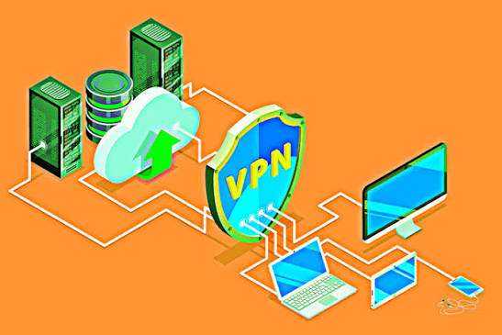
Definition:
VPN is a technology that creates a secure and encrypted connection over a public network such as the Internet.

Characteristics
- Provides encrypted communication.
- Allows secure remote access to a private network.
- Can protect data from unauthorized access.
- Uses VPN protocols to establish a secure connection.
- Can connect users to a network from different locations.

Advantages
- Improves privacy and security.
- Protects data while using public networks.
- Allows employees to securely access office resources remotely.
- Useful for remote working.
- Can help protect sensitive information from interception.

Disadvantages
- May reduce Internet speed because of encryption and routing.
- Some VPN services require payment.
- Configuration can be complicated for beginners.
- The VPN provider may potentially see some connection information.
- A VPN does not protect against every type of cyberattack.

Wi-Fi – Wireless Fidelity

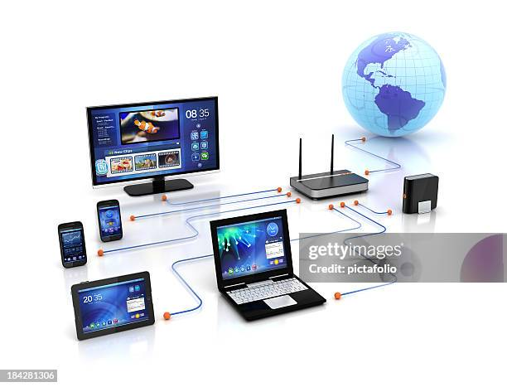
Definition:
Wi-Fi is a wireless networking technology based on IEEE 802.11 standards that allows devices to connect to a network and access the Internet using radio waves.

Characteristics
- Uses radio waves for communication.
- Provides wireless Internet and network access.
- Commonly uses a wireless router or access point.
- Supports laptops, smartphones, tablets, smart TVs, and IoT devices.
- Can support multiple devices simultaneously.

Advantages
- No cables are required for connecting devices.
- Easy and convenient to use.
- Allows mobility within the coverage area.
- Easy to connect multiple devices.
- Widely available in homes, offices, colleges, airports, and public places.

Disadvantages
- Limited coverage range.
- Can suffer from interference.
- Wireless networks require proper security configuration.
- Speed can decrease when many users share the network.
- Physical obstacles such as walls can weaken signals.

GAN – Global Area Network
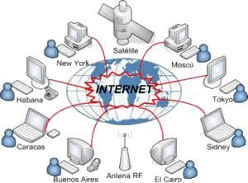
Definition:
GAN is a network that connects computers and networks across very large geographical areas, potentially worldwide.

Characteristics
- Covers countries, continents, or the entire world.
- Connects multiple WANs and other networks.
- Uses technologies such as fiber-optic links, satellites, and undersea cables.
- Supports global communication and data sharing.
- Requires large-scale network infrastructure.

Advantages
- Enables worldwide communication.
- Allows organizations to connect offices in different countries.
- Supports global data and resource sharing.
- Makes international services possible.
- Provides access to services from different geographical locations.

Disadvantages
- Very expensive to establish and maintain.
- Complex to manage.
- Security risks are higher because of its large scale.
- Network failures can affect communication across large areas.
- Performance depends on long-distance connections and network infrastructure.

